Questions for Reflection and Sharing

What connections or new insights did you gain from the readings?

What words or phrases spoke to you most powerfully
in light of the call to form our parish as a beacon of light?

How might the readings influence our planning for the future?

Intercessions

For what or for whom should we pray?

Lord’s Prayer
Closing Prayer

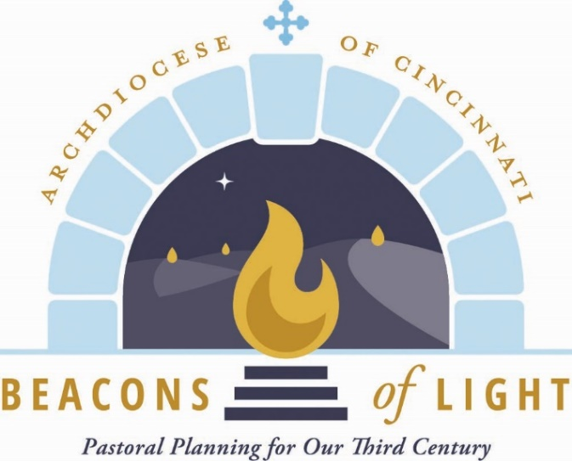
September 2021

Opening Prayer

Let us pray.

(Pause for silent prayer)

Mary, Mother of the Church and our Mother,
Present our prayer of thanksgiving to your Son.
Beg from Him the graces we need to be faithful disciples
who follow Him with enthusiasm and joy.
May our witness to the love of God bear fruit
in our archdiocese, parishes, homes and hearts.
Teach us to be God’s joyful witnesses,
to radiate Christ in all we do,
so that all people might know, love and follow your Son
through this life and into the next. Amen.
Grant, we pray, almighty God,
that your Church may always remain that holy people,
formed as one by the unity of Father, Son, and Holy Spirit,
which manifest to the world
the Sacrament of your holiness and unity
and leads it to the perfection of your charity.

Through our Lord Jesus Christ, your Son,
who lives and reigns with you in the unity of the Holy Spirit,
God, forever and ever. Amen.

Reading from Sacred Scripture

A reading from the Gospel according to St. Mark.

Again Jesus left the district of Tyre
and went by way of Sidon to the Sea of Galilee,
into the district of the Decapolis.
And people brought to him a deaf man who had a speech impediment
and begged him to lay his hand on him.
He took him off by himself away from the crowd.
He put his finger into the man’s ears
and, spitting, touched his tongue;
then he looked up to heaven and groaned, and said to him,
“Ephphatha!” – that is, “Be opened!” –
And immediately the man’s ears were opened,
His speech impediment was removed,
and he spoke plainly.
He ordered them not to tell anyone.
But the more he ordered them not to,
the more they proclaimed it.
They were exceedingly astonished and they said,
“He has done all things well.
He makes the deaf hear and the mute speak.”

(Mk 7:31-37) Twenty-third Sunday in Ordinary Time)

From Families of Parishes as Evangelizing Communities
Fr. Earl Fernandes in the Catholic Telegraph

First, we are a Church that goes forth. We are missionaries. Going forth demands courageously leaving our comfort zone.
Second, the community of missionary disciples shows initiative. The Spanish word primerear captures this idea of being proactive rather than reactive. Here in the Archdiocese of Cincinnati, we cannot afford to wait for people to come to us; rather, we must seize the initiative and become “spiritual entrepreneurs.”
Third, the evangelizing community is engaged with its members. Pope Francis sometimes uses the word balconear, which means to stand on the balcony to see what is happening without personal engagement. The priest cannot do everything. He must encourage his people to get involved by identifying and utilizing the talents and gifts of his flock.
Fourth, a community of missionary disciples accompanies others. A father of a family must lead his family, spend time with his family and offer encouragement, keeping the family together. Accompaniment entails guiding, encouraging, supporting and uniting. The pastor must lead the process, accompanying his own people, learning about their joys, sorrows, hopes and needs, and offering encouragement. This demands listening and empathizing on his part. At the same time, the parish community walks with him, with each member playing a role in strengthening each other, serving as bridges, rather than barriers, in a united effort to evangelize.
Fifth, the evangelizing community is fruitful. Fruitfulness demands discernment and patience. The parable of the weeds and wheat speaks of discerning what is from the Son of Man, who sows good seeds in the field, from the weeds, sown by the devil. Jesus warns of the need to be patient and discerning because things are not always initially clear. Patience and discernment allow us to move forward. It is particularly necessary for all of us to help the faithful understand why Beacons of Light is happening and to accept the reality of change.
The final characteristic of an evangelizing community is joy. The Eucharist is the sacrament of Christian joy. In the Eucharist, the joy Jesus has won is not only preserved and shared, but perdures. The Church celebrates the Eucharist with the spousal joy of one promised to Christ. It is a foretaste of the heavenly banquet.

