Questions for Reflection and Sharing

What connections or new insights did you gain from the readings?

What words or phrases spoke to you most powerfully
in light of the call to form our parish as a beacon of light?

How might the readings influence our planning for the future?

Intercessions

For what or for whom should we pray?

Lord’s Prayer
Closing Prayer

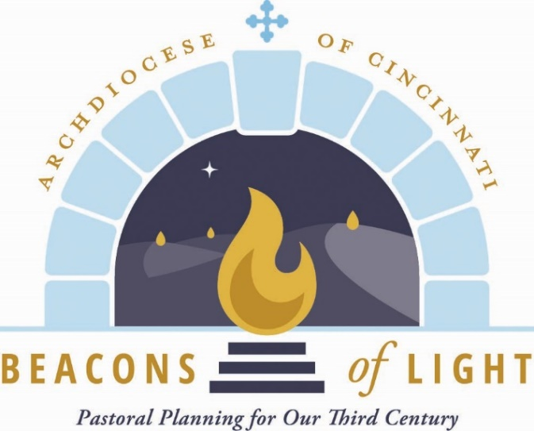
August 2021

Opening Prayer

Let us pray.

(Pause for silent prayer)

Mary, Mother of the Church and our Mother,
Present our prayer of thanksgiving to your Son.
Beg from Him the graces we need to be faithful disciples
who follow Him with enthusiasm and joy.
May our witness to the love of God bear fruit
in our archdiocese, parishes, homes and hearts.
Teach us to be God’s joyful witnesses,
to radiate Christ in all we do,
so that all people might know, love and follow your Son
through this life and into the next. Amen.
Grant, we pray, almighty God,
that your Church may always remain that holy people,
formed as one by the unity of Father, Son, and Holy Spirit,
which manifest to the world
the Sacrament of your holiness and unity
and leads it to the perfection of your charity.

Through our Lord Jesus Christ, your Son,
who lives and reigns with you in the unity of the Holy Spirit,
God, forever and ever. Amen.

Reading from Sacred Scripture

A reading from the Gospel according to St. Luke.

Mary set out
and traveled to the hill country in haste
to a town of Judah,
where she entered the house of Zechariah
and greeted Elizabeth.
When Elizabeth heard Mary’s greeting,
the infant leaped in her womb,
and Elizabeth, filled with the Holy Spirit,
cried out in a loud voice and said,
“Blessed are you among women,
and blessed is the fruit of your womb.
And how does this happen to me,
that the mother of my Lord should come to me?
For at the moment the sound of your greeting reached my ears,
the infant in my womb leaped for joy.
Blessed are you who believed
that what was spoken to you by the Lord
would be fulfilled.”

And Mary said:

“My soul proclaims the greatness of the Lord;
my spirit rejoices in God my Savior
for he has looked with favor on his lowly servant.
From this day all generations will call me blessed:
the Almighty has done great things for me
and holy is his Name.
He has mercy on those who fear him
in every generation.
He has shown the strength of his arm,
and has scattered the proud in their conceit.
He has cast down the mighty from their thrones,
and has lifted up the lowly.

He has filled the hungry with good things,
and the rich he has sent away empty.
He has come to the help of his servant Israel
for he has remembered his promise of mercy,
the promise he made to our fathers,
to Abraham and his children forever.”

Mary remained with her about three months
and then returned to her home.

(Lk 1:39-56 Solemnity of the Assumption of the Blessed Virgin Mary)

From Radiate Christ

Will I radiate Christ
so that others can know His goodness and love?
My brothers and sisters,
Christ wants to do so much through us.
Let us take advantage of the opportunity before us
to renew our willingness to let Him.
This letter serves many purposes.
It is a petition that we each seek to know Jesus Christ.
It is an invitation to discover the joy in following Him.
It is a word of encouragement when the road of discipleship
becomes difficult.
It is a proclamation of the beauty
of being a joyful witness by radiating Christ.
As we celebrate together the
good things God has done in our archdiocese,
let us also pray together that He continues to
bless us with His presence and His love,
entrusting ourselves to the care of our Blessed Mother.

